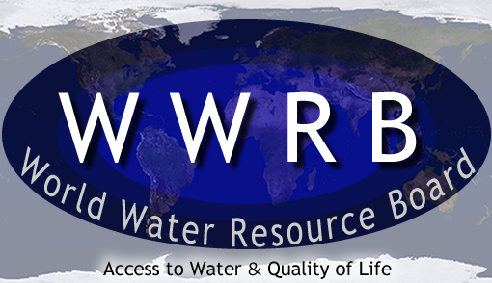
GLOSSARY

Arid | Extremely dry; without moisture.
Compound Measure | Combination of two or more measures by applying a mathematical operation such as multiplication or division.
Cubic Metre | A container measuring one metre in length, width and depth.
Mathematical Procedure | Addition, subtraction, multiplication and division are examples of these.  Also known as mathematical operation.
Plateau | An area of high flat land; a mountain with a wide, flat top.
Square Kilometre | A square measuring one kilometre on each side.
Terrain | The surface features of an area of land.
Total Area | Amount of land in a country.
Total Population | Everyone living in a country.
Total Water Available | The amount of water in a country in a year. This includes rivers, rain, and other water sources.
Units | Any specified amount of a quantity (as of length, volume, force, momentum, or time) that serves as a standard and facilitates comparisons.

